# Karachi:

# PAF Museum

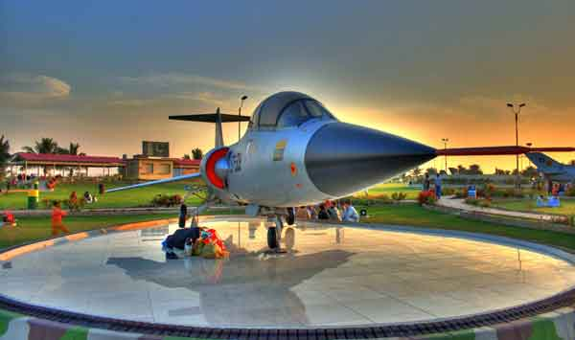

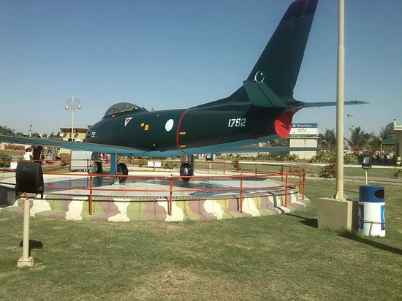

**PAF Museum, Karachi** is an Air Force museum and park situated near Karsaz Flyover on Shahrah-e-Faisal in Karachi,Sindh, Pakistan.A majority of the aircraft, weapons and radar are displayed outside in the park but the main museum features all major fighter aircraft that have been used by the Pakistan Air Force. The museum also houses the Vickers VC.1 Viking aircraft used by Mohammed Ali Jinnah, founder of Pakistan, and a Folland Gnat of the Indian Air Force, that landed in Pasrur town, Pakistan in the Indo-Pakistani war of 1965. Also on display are the scale models of some World War I, World War II and some more modern aircraft and photo galleries of almost all the squadrons of Pakistan Air Force.